A Word template for Tektonika

A. Firstauthor1*, B. Secondauthor2, C. Thirdauthor1,2, and D. Relegated2

1Department of Geology, A University, Acity, UK

2School of Earth Sciences, Another University, Bcity, Norway

*Corresponding author (e-mail: afirstauthor@auniversity.ac.uk)

Abstract

#### Abstract text goes here - **no more than 250 words.** Please use only the styles included in this template: MS title, Authors, Affiliations, Abstract, Normal (for text), and Headings (levels 1–3). Figures can be embedded in this document, or uploaded as separate files. If they are included in the manuscript file, place them at the end of the text, along with any tables. Please use the Caption style.

# Section (as Heading 1)

The main body of the text should go here.

## Subsection (as Heading 2)

Figure sizes should not exceed 85 × 200 mm (for single column figures) or 175 × 200 mm (for two column figures).

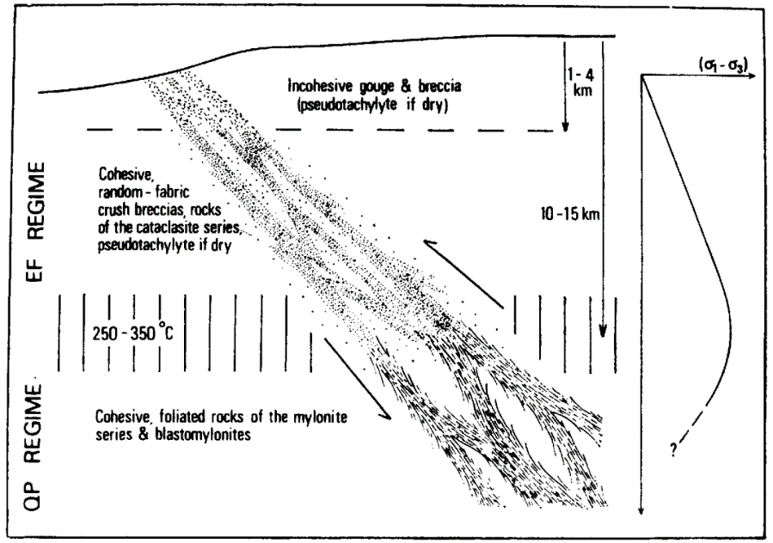

Figure 1: Conceptual model of a major fault zone.

### Subsubsection (as Heading 3)

Define any equations in the Equation environment:

$\dot{ε}=Aσ^{n} f_{{\text{H}}_{\text{2}}\text{O}}^{r} e^{(\frac{-Q}{RT})}$ (1)

# More sections

Citations may either be inline Sibson (1977) or in parentheses (Sibson, 1977).

Acknowledgements

Thank all relevant parties and acknowledge funding sources, if any.

Author contributions

Tell us who did what.

Data availability

Authors should direct readers to an open access repository such as figshare, Github or Pangea where data are made available.

References

References should be included at the end of the manuscript, in APA style: <http://www.bibme.org/citation-guide/apa/>

Where possible, DOI numbers should be provided.

Author, A. (Publication Year). Article title. *Periodical Title*, Volume(Issue), pp.-pp.

Einstein, A. and Rosen, N. (1935). The particle problem in the general theory of relativity. *Physica Review*, 48(1):73. doi: 10.1103/PhysRev.48.73